**Successful fertiliser spreading  
Discover the additional revenue generated with the AMAZONE border spreading calculator**

Amazone offers various technical solutions and services for optimising the adjustment of fertiliser spreaders. Accurate, tailored fertiliser application plays a critical role in reducing costs and protecting the environment. Specially for spreading along field borders, Amazone TS fertiliser spreaders feature the tried-and-tested disc-integrated AutoTS border spreading system. The added value generated by AutoTS, compared with conventional border spreading systems, can now be calculated using the new border spreading calculator. The calculator is available online from Amazone in seven languages –   
[www.amazone.net/border-spreading-calculator](http://www.amazone.net/border-spreading-calculator)

Amazone border spreading systems are not only precise, but comfortable and flexible to use too. AutoTS lets you select between the different border spreading processes – side, boundary and water course spreading – from the comfort of the tractor cab. Depending on the respective border spreading situation, different settings can be used:

for example, if the field borders onto land with a similar crop, 100% of the application rate can be spread up to the edge of the field using side spreading.

If the field borders on a road or public footpath, the spreader switches to boundary spreading. This reduces the maximum throwing distance to the edge of the field. This prevents fertiliser from being thrown across the border.

If there are any streams, water courses, open water or other areas under ecological management in the direct vicinity of the field, the water course spreading option ensures the required distance is kept within the confines of the field. This helps protect the environment whilst ensuring the highest possible yield along the field boundary.

Amazone has tested the AutoTS border spreading system in practice for several years. In large-scale field trials, artificial field borders were created within fields to minimise the influence of external factors, such as areas of shadow, years of under-fertilisation or competition for water by hedges and trees. During these trials, the AutoTS system was compared to other conventional border spreading techniques under practical conditions, at a tramline width of 24 m and the distribution of the total fertiliser quantity split across three passes. Calcium ammonium nitrate was used in each of the three applications.

The final yield suggested that there was a significant difference between these border spreading techniques on the outer five metres of the plots. Using a conventional border spreading system, an average yield of 68 percent of the reference yield for the full field was achieved in the border zone. With Amazone AutoTS, an average of 85 percent of the reference yield was achieved. This means the average increase in yield when using an Amazone fertiliser spreader with AutoTS is around 17 percent, compared to conventional techniques.

By using a modern border spreading system, it is possible to generate increased income compared with conventional systems, even in small fields because the smaller or more irregularly shaped the plot, the greater the border area. By entering the yield and return for different crops, the Amazone border spreading calculator can easily calculate the added revenue that could be generated. As well as increasing yields along the borders of the field, AutoTS also helps reduce the amount of fertiliser applied outside the edges of the field, which helps protect the environment.

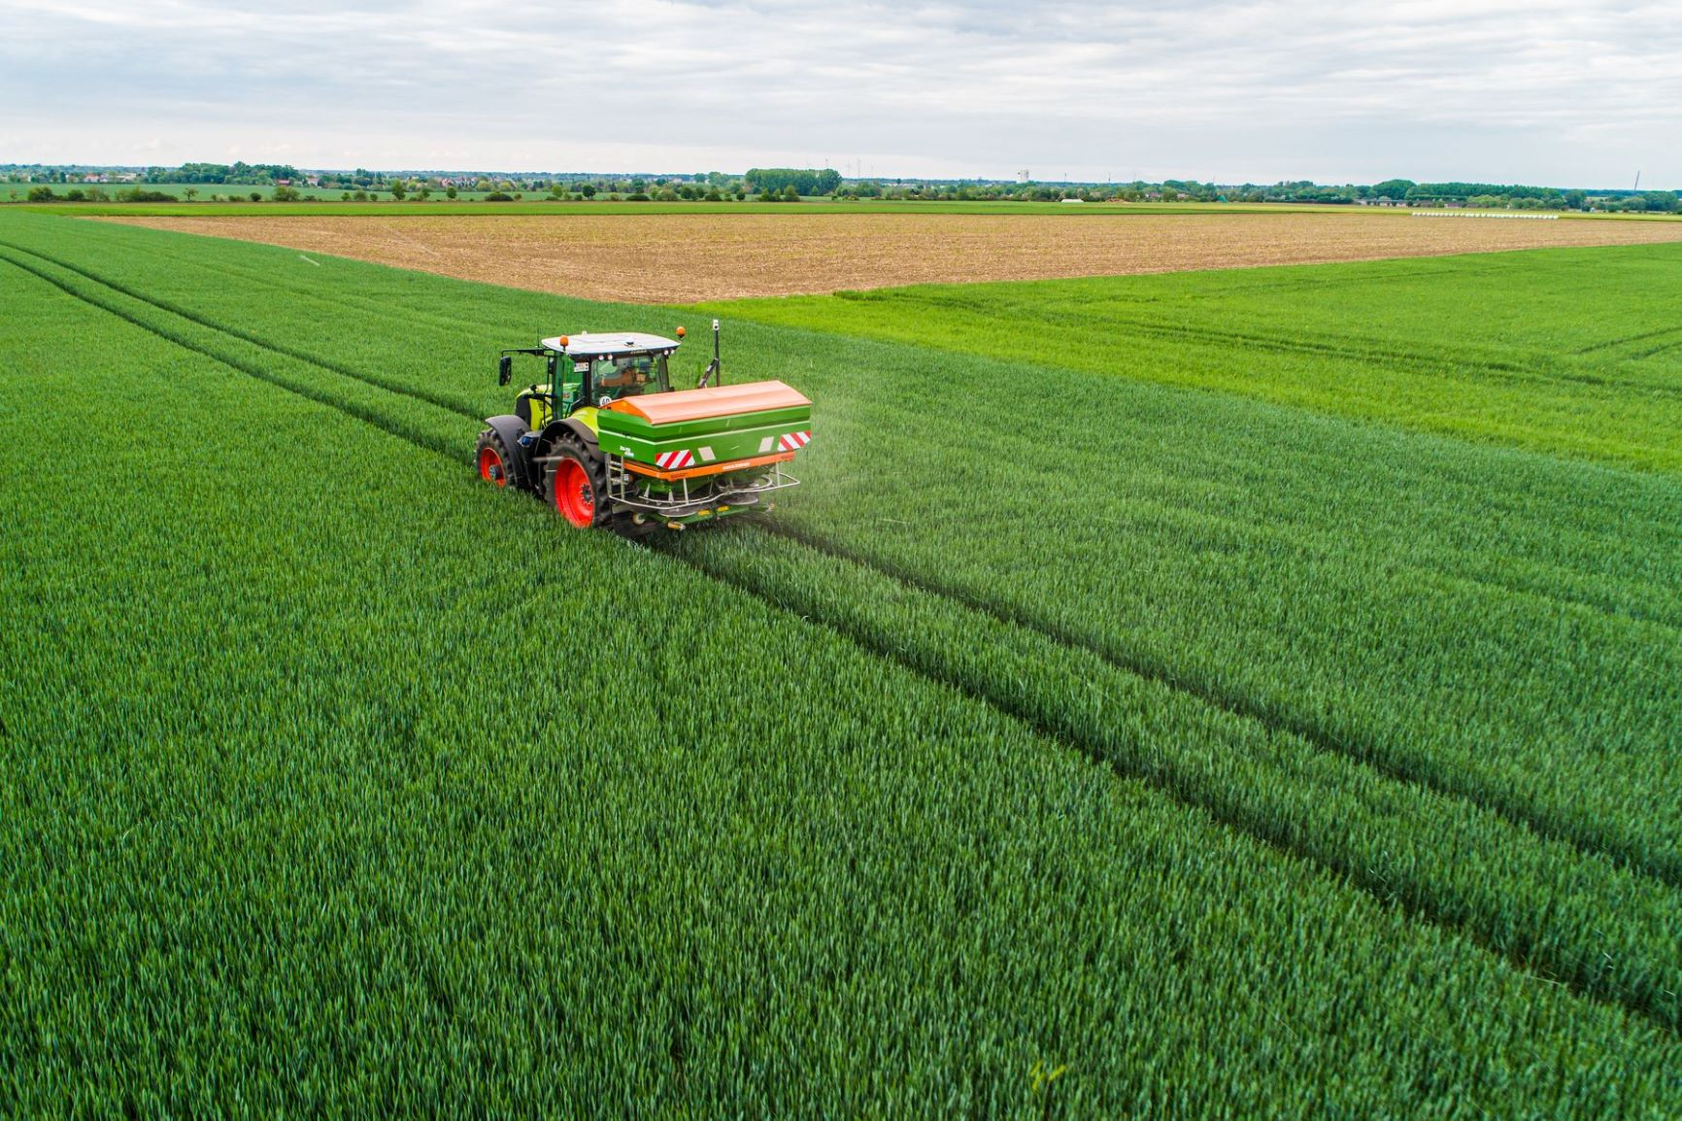

Uniform crops up to the edge of the field with AutoTS.

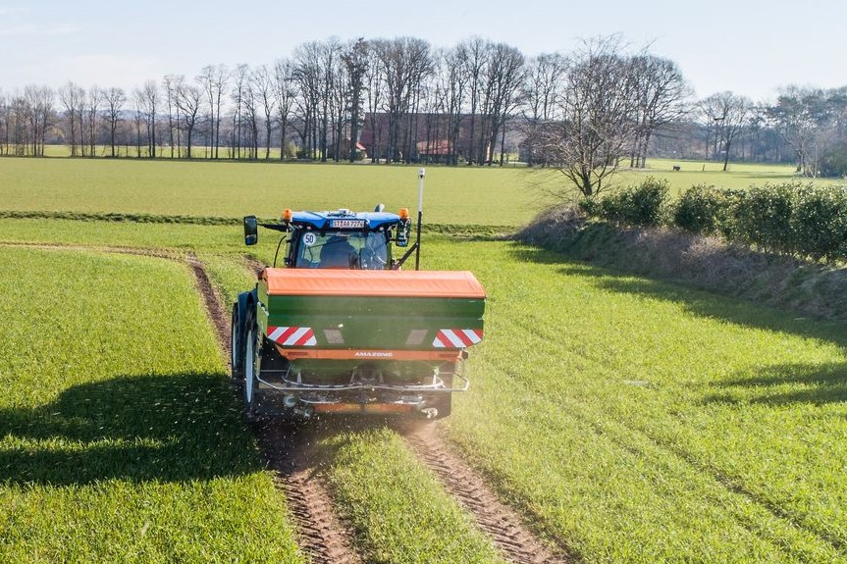

Border spreading – precise spreading of fertiliser up to hedges, footpaths or field boundaries.

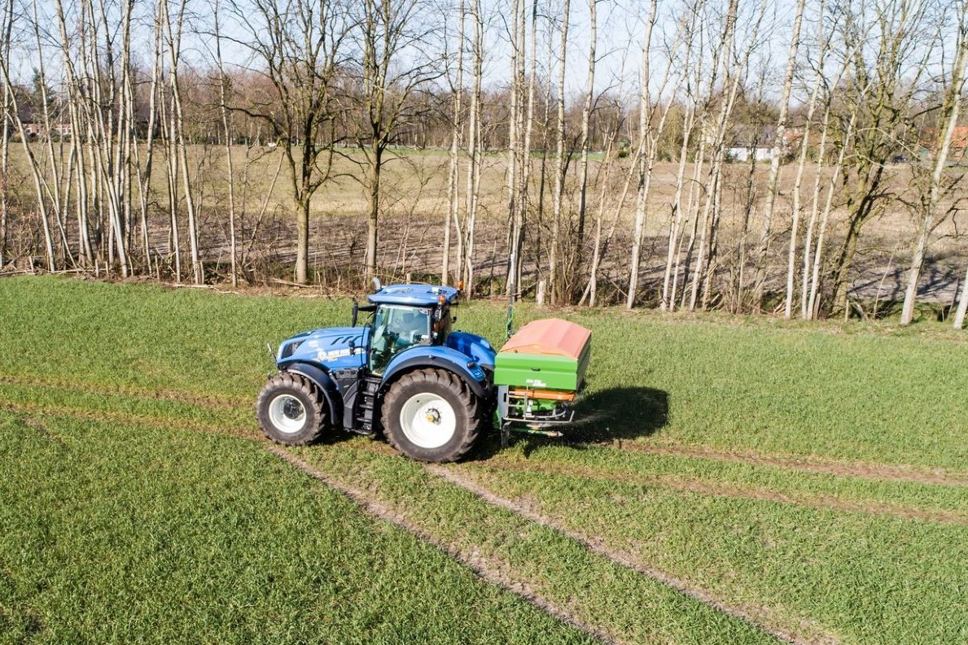

High yields along water courses: with the Amazone settings for water course spreading.

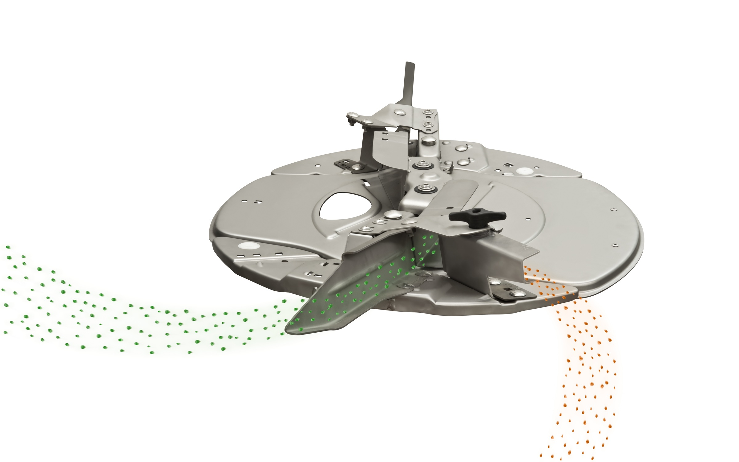

Functional principle of AutoTS: two fertiliser application methods. Normal spreading – long blade Border spreading – short blade

**About AMAZONE**

AMAZONEN-WERKE H. Dreyer GmbH & Co.KG, based in Hasbergen-Gaste in Germany, manufactures agricultural and groundcare machinery. The owner-managed company employs around 1900 people at nine different production sites in Germany, France, Russia and Hungary. The agricultural machinery range includes soil tillage implements, seed drills, fertiliser spreaders and plant protection equipment.

Based on these core competencies, AMAZONE is now the specialist for intelligent crop production in agriculture.

Further information: [www.amazone.net](http://www.amazone.net)

[cid:FB_70d43fd1-a841-4de4-bbaa-3e1f495f95d3.jpg](https://www.facebook.com/amazone.group) [cid:IG_efb650a7-31e4-4674-98db-f2d2d5c58dce.jpg](https://instagram.com/amazone_group) [cid:YT_e9180d16-5a2b-4618-92e9-22a015f9cafb.jpg](https://www.youtube.com/user/amazonede) [cid:LinkedIn_80de4e9c-c7a3-41e3-8e11-063f7eace13d.jpg](https://www.linkedin.com/company/amazone-group/) [cid:Xing1_e3730686-2953-47a9-9c47-dbaa518a9207.jpg](https://www.xing.com/company/amazone)